1st Annual ELT Ireland Conference
21st – 22nd February, DBS Dublin, Ireland

The Association of Teachers of English of the Czech Republic is pleased to have signed a partnership agreement with ELT Ireland, and I was glad I to be the representative of our association at the 1st Annual ELT Ireland Conference. The theme of the conference was Destination Education: The next step in a connected world for ELT learners, teachers and managers. The conference was therefore not only aimed at teachers of English but also teacher trainers and managers in education. The conference was open on Saturday morning by a welcome talk by Dr Lou McLaughlin. The first plenary session by Fiona Thomas followed. Her talk was called Destination Education and it was primarily focused on management. The next plenary session was done by Dr Caroline Linse. Dr Linse shed lingt on the Avenues and Obstacles to Plurilingualism.
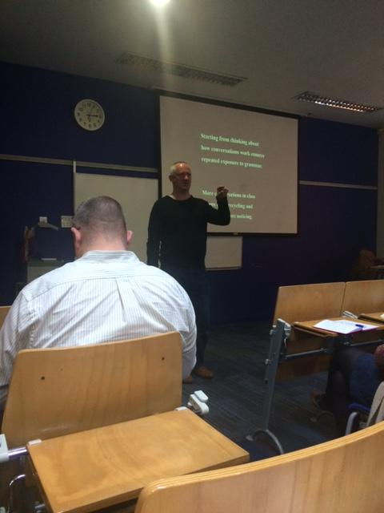
I led a workshop after the plenary sessions. Iargued that it is a centred teacher who should enter the classroom, and that as teachers we might want to help students arrive in the here and now of the English lesson. Participants of the workshop shared share meaningful activities which help turn teachers’ and students’ attention back to themselves. They participated in activities aimed at regaining energy and enhancing attention. I also presented a teacher training which will take place at a music festival between 15th and 19th July 2015 in Ostrava, the Czech Republic: The Sounds, Smells and COLOURS OF OSTRAVA - Tasteful and Touching Teacher Training: http://www.hello.cz/cs/projekty-a-vzdelavani/erasmus. After my workshop, I attended a workshop led by Dr Kizilicik & Dr SalliCopur and Hugh Dellar’s plenary Teaching Grammar Better. After that I decided to listen to Joanne Mitten who talked on Supporting your workforce: Developing in-house CPD for long term teachers and Susiati Francoiz who provided insight into Identity theories: understanding the learning process of Indonesian EFL students. The final plenary session of the day was Sue Hackett’s Assessments of (and for) learning: enhancing and improving learning through assessment framework.

On Sunday we had a chance to listen to the Introduction to ELT-Education & Development by Peter Lahiff from ELT Ireland and a series of ELT-ed talks. ELT-ed talk is a format which is 12 minutes long (12 minutes for presentation & 2-3 minutes for questions). The talks were recorded and I believe you can find them with many others from previous ELT Ireland events on the Internet. The closing plenary was presented by Shaun Wilden whose talk was centred around the question: Does mobile learning make you ‘appy?

On a more personal note, I’d like to add a bit of my story about my stay in Dublin. It’s been a while I stopped watching TV series of any kind but my favourite character remains Dylan Moran’s Bernard Black in Black Books. He is a drunken, grumpy, cynical, and often neurotic owner of a bookshop in London of Irish origin. In fact, it was not only Dylan Moran who made me realize that it is indeed the Irish accent which belongs among my favourite ones. How’s the Craic? is an Irish phrase which means approximately How’s life treating you? And it is a common greeting in Ireland. In reply, you can choose one of the following expressions: Gas! (good), Mighty! (very good), Unbelievable! (extremely good), Poor! (bad), Useless! (very bad). You can also simply moan: There’s no Craic! Eventually if you’re really enjoying yourself you could use a phrase of a mysterious etymology: Craig is 90! The language, the prehistoric sights, celtic traditions, and the famous beauty of Irish countryside are just a few of many reasons why I’ve always been attracted to the country and its culture. Therefore, I decided to prolong my stay on my own expenses and spend one full day as a tourist. I decided to explore Newgrange which is a prehistoric sight. Newgrange can be reached within two hours ride by public transport. Interestingly, only when I got back home, I realized that Dylan Moran comes from Navan, a place just 20 km from Newgrange.
To conclude, it was my utmost pleasure to attend the 1st ELT Ireland Annual Conference and I'm keeping my fingers crossed for all their future projects. I'm looking forward to hosting an ELT Ireland representative at our 10th International and 15th National ATECR Conference 2015 SHADES OF ELT which will take place in Uherske Hradiste in the Czech Republic in September: http://atecr.weebly.com/2015-shades-of-elt.html.
.


Daniela Valíková holds a Master’s degree in Teaching English and German, and has been studying ELT Methodology in a doctoral study programme at Charles University in Prague. She teaches university and in-company language courses, cross-cultural communication and soft skills; and is a Regional Coordinator of ATECR. Her research interests include ESP, cross-cultural etiquette, relaxation techniques, and pedagogic uses of mental imagery.

